Hotdog Day - at Rich Valley School
Tuesday, January 16.
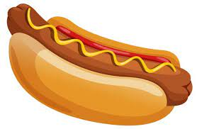
Due to the cold weather and buses not running on Thursday, Jan 11 our hotdog day scheduled for that day was canceled and moved to Tuesday, Jan 16. So bring in your loonie and enjoy a hotdog.

